**SUMATIF TENGAH SEMESTER GANJIL**

**MADRASAH IBTIDAIYAH KECAMATAN SINGOSARI**

**TAHUN PELAJARAN 2024/2025**

|  |  |  |  |  |  |
| --- | --- | --- | --- | --- | --- |
| **Mata Pelajaran** | **:** | **Bahasa Inggris** | **Nama** | **:** |  |
| **Kelas** | **:** | **III (Tiga)** | **Hari/Tgl** | **:** |  |

1. **Berilah tanda silang (x) pada huruf a, b, c dan d pada jawaban yang tepat!**
2.  I like …

a. hot coffee c. orange juice

b. milk d. ice tea

1. 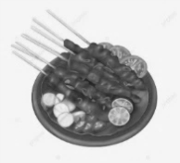Mr. Ardi likes …

a. french fries c. satay

b. fried chicken d. meatballs

1. 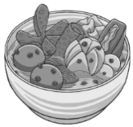

Me and my sister like …

a. cake b. salad c. noodle d. meatball

1. We have the same favourite food.

The food shape is silinder and long.

It means we like …

a. sausage b. pizza c. cake d. burger

1. The food is for birthday party

I like …

a. soto b. cake c. noodle d. dim sum

1. I don’t like …



a. mango juice

b. hot tea

c. mineral water

d. soda

1. He likes …

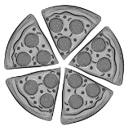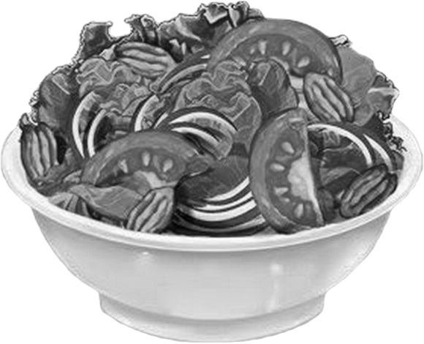

a. pizza

b. burger

c. salad

d. fried rice

1. It is like bread, but it has sauce, slice of meat and some vegetables.

I like …

a. satay b. cake c. fried rice d. burger

1. We have dinner in the …

a. morning b. afternoon c. evening d. night

1. When we eat in the morning, it is called …

a. lunch b. dinner c. brunch d. breakfast

1. 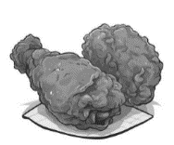

My brother … fried chicken.

a. like b. likes c. didn’t like d. don’t like

1. Ariel … soda

a. like c. don’t like

b. likes d. doesn’t like

1. 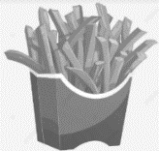I … french fries

a. don’t like c. like

b. likes d. doesn’t like

1. 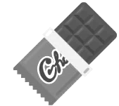They … chocolate

a. don’t like c. doesn’t like

b. likes d. like

1. It is a good drink for health, it has not colour.

Budi always drinks it.

He likes …

a. mineral water b. coffee c. orange juice d. ice tea

1. Putra : What food do you like?

Ayu : I … fried rice

a. likes b. like c. didn’t like d. doesn’t like

1. Doesn’t – Budi – orange juice – like

a. Budi doesn’t orange juice like c. doesn’t like Budi orange juice

b. Budi doesn’t like orange juice d. doesn’t like orange juice Budi

1. Likes – burger – He – and – soda

a. He likes burger and soda c. He burger likes and soda

b. likes He burger and soda d. likes burger He and soda

1. “Breakfast” in Indonesia means …

a. makan malam b. makan siang c. sarapan d. makan bersama

1. 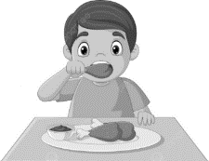 Alby has … for …

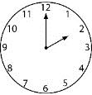 a. french fries, lunch

b. fried rice, breakfast

c. fried chicken, lunch

d. fried rice, dinner

1. “lunch” in Indonesia means …

a. sarapan b. makan siang c. makan malam d. makan sore

1. 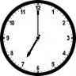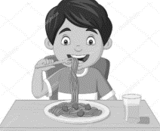Aris has … and … for …

a. fried rice, milk, dinner

b. seafood, milk, lunch

c. noodle, mineral water, lunch

d. noodle, mineral water, dinner

1. 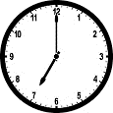I have … for …

a. soto, lunch

b. cake, dinner

c. salad, dinner

d. sausage, breakfast

1. 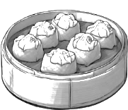I like …

a. dim sum

b. scrumbled egg

c. fried rice

d. fried egg

1. 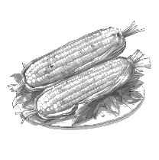She doesn’t like …

a. bread c. soto

b. pizza d. burned corn

1. **Jodohkan pertanyaan berikut dengan jawaban yang tepat !**

| **No.** | **Pertanyaan** |  | **Jawaban** |
| --- | --- | --- | --- |
| 1. | Yudha really likes burger | **(….)** | **a)** |
| 2. | Ms. Fardiani likes ice cream | **(….)** | **b)** |
| 3. | Mr. Firman doesn’t like cake | **(….)** | **c)** |
| 4. | They don’t like salad | **(….)** | **d)** |
| 5. | Aisyah drinks mineral water | **(….)** | **e)** |

1. **Jawablah dengan singkat pertanyaan di bawah ini!**
2. 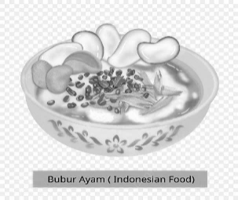 I ……… porridge.
3. 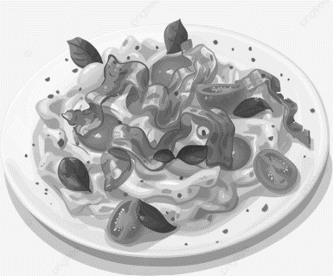 They ……..… scrambled egg.
4. 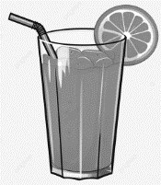 He ………… orange juice
5. 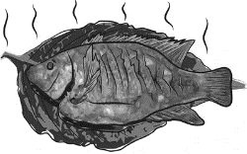 She likes …………
6. 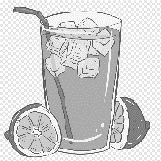 Rudi and Ari ………… lemon tea.
7. **Jawablah pertanyaan di bawah ini dengan benar !**
8. Mention three foods!

…………………………………………………………………………………………………….

1. Mention three drinks!

…………………………………………………………………………………………………….

1. “Saya suka nasi goreng” in english is!

…………………………………………………………………………………………………….

1. “Putri tidak suka jus apel” in english is!

…………………………………………………………………………………………………….

1. “Ayahku dan Ibuku tidak suka es krim” in english is!

…………………………………………………………………………………………………….