**SUMATIF TENGAH SEMESTER GANJIL**

**MADRASAH IBTIDAIYAH KECAMATAN SINGOSARI**

**TAHUN PELAJARAN 2024 / 2025**

|  |  |  |  |  |  |
| --- | --- | --- | --- | --- | --- |
| **Mata Pelajaran** | **:** | **BAHASA INGGRIS** | **Nama** | **:** |  |
| **Kelas** | **:** | **I (Satu)** | **Hari/Tgl** | **:** |  |

1. **Berilah tanda silang (x) pada huruf a, b dan c pada jawaban yang tepat!**
2. Look at the picture. The correct greeting is ….
3. 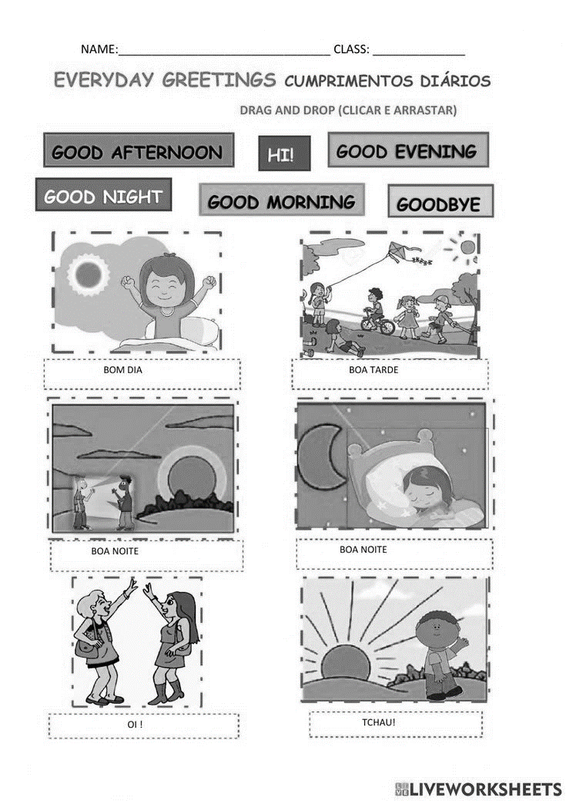good morning
4. good evening
5. good afternoon
6. Look at the picture. The best parting is ….
7. 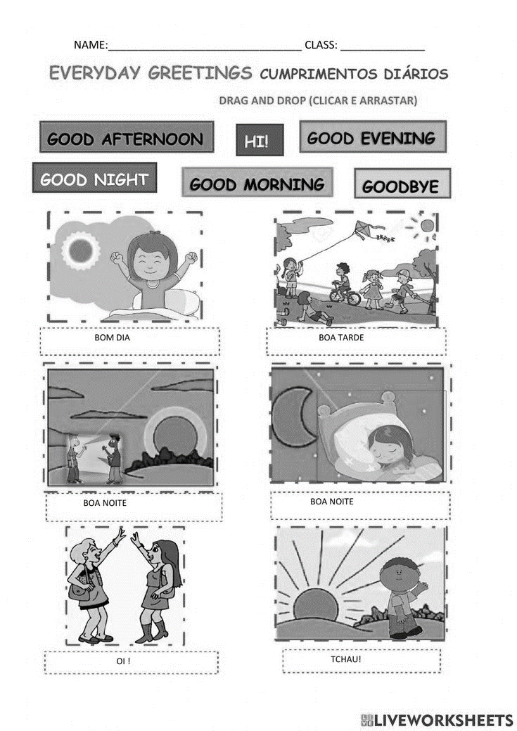good afternoon
8. good evening
9. good night
10. Rani : Hello, Danu.

Danu : …., Rani.

a. good morning b. hello c. good night

1. Mr. Bian : Good afternoon Ana.

Ana : …., Sir.

a. good afternoon b. good bye c. good morning

1. Leli : How are you today?

Dira : ….

1. see you b. i am fine c. thank you
2. Andi : ….

Runa : Nice to meet you too.

a. good bye b. thank you c. nice to meet you

1. Cila : ....

Nabila : see you tomorrow.

a. how are you b. see you tomorrow c. good morning

1. Look at the picture.

I am a ….

a. librarian

b. teacher

c. student

1. Look at the picture.

I am a ….

a. librarian

b. teacher

c. student

1. The word “librarian” in Indonesian is….
2. pustakawan b. guru c. murid
3. Risa : Are you Erwin Wibowo?

Erwin : yes, ….

1. you are b. i am c. he is
2. My name is ….
3. Ayu siska b. Malang c. playing football
4. Look at the picture. A : What is your name?

B : My name is ....

1. Cici
2. Citra

**Citra**

1. Cila
2. Look at the picture. A : Is she Mrs Indira?

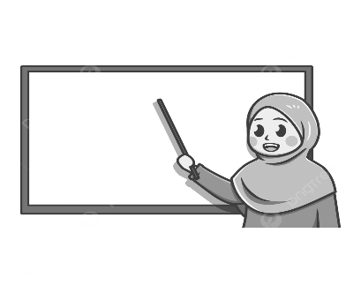B : Yes, ....

1. she is not

**Indira**

1. he is
2. she is
3. Choose the correct picture. My name is Lintang.

a. b. c.

**Bintang**

**Gilang**

**Lintang**

1. Sari : How … are you?

Cevin : I am seven years old

a. name b. old c. hobby

1. Tasya : Where do you live?

Bima : ….

1. I am six years old b. I am Bima c. I live in Malang
2. Look at the picture. Ana : Who is he?

Dian : He is my father.

Ana : What is he?

Dian : he is a ....

1. doctor b. driver c. police
2. Look at the picture. Fajar : Is he a teacher?

Budi : No, he is not

Fajar : What is he?

Budi : he is a ....

1. driver b. doctor c. soldier
2. It is number ….

**4**

three

four

five

1. It is number ….

**9**

nine

eight

ten

1. Look at the picture. Sofi : How many oranges do you have?

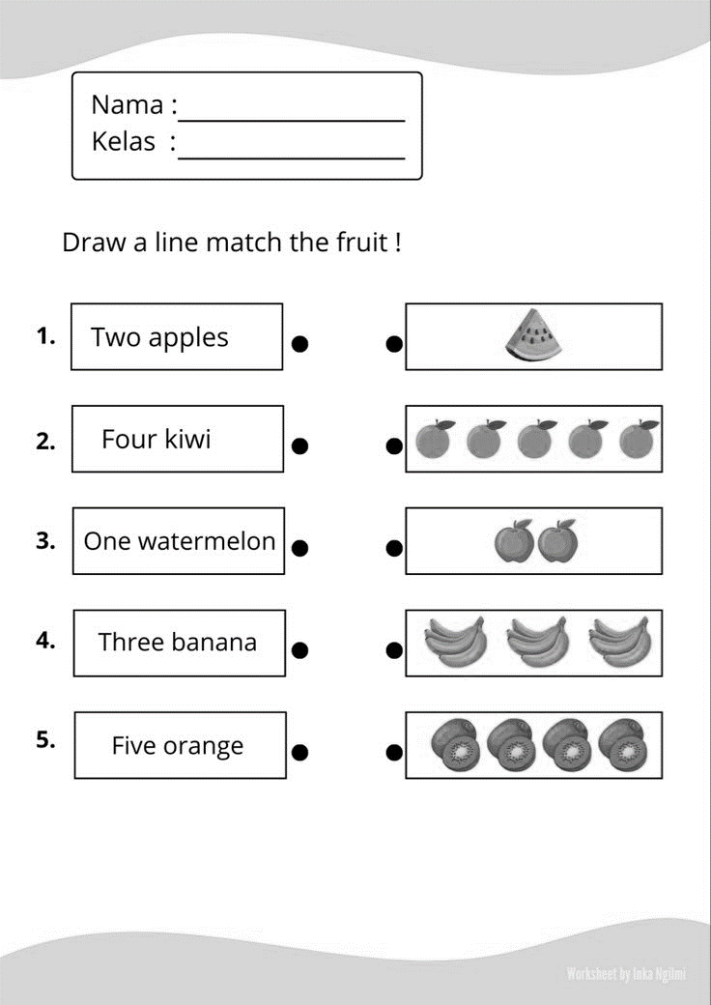Nindi : I have ....

1. six oranges
2. five oranges
3. seven oranges
4. Zaki : what is the number after six?

Alim : It is ….

a. seven b. eight c. five

1. Look at the picture There are …. balloons

five

four

six

1. Akifa have three books.

a. 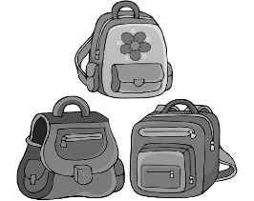 b.  c. 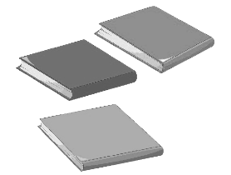

1. **Ayo pasangkan pertanyaan dengan jawaban yang benar!**

|  |  |  |  |  |  |
| --- | --- | --- | --- | --- | --- |
| **No** | **Pertanyaan** |  |  |  | **Jawaban** |
| 1. | Good night |  |  | I am fine |
| 2. | Selamat tinggal |  |  | Selamat malam |
| 3. | How are you? |  |  | 10 |
| 4. | How old are you? |  |  | Good bye |
| 5. | It is number ten |  |  | I am seven years old |

1. **Jawab dengan singkat pertanyaan di bawah ini!**
2. Gilang : Good morning, Sir.

Mr. Indra : Good ……

1. My .…………. is Melinda Maulidia.
2.  My name is Reihan Saputra.

I am a ……..

1.  There are …….… bananas.
2.  I have …………….Fingers.