**SUMATIF TENGAH SEMESTER GANJIL**

**MADRASAH IBTIDAIYAH KECAMATAN SINGOSARI**

**TAHUN PELAJARAN 2024 / 2025**

|  |  |  |  |  |  |
| --- | --- | --- | --- | --- | --- |
| **Mata Pelajaran** | **:** | **Bahasa Inggris** | **Nama** | **:** |  |
| **Kelas** | **:** | **ll (Dua)** | **Hari/Tgl** | **:** |  |

1. **Berilah tanda silang (x) pada huruf a, b dan c pada jawaban yang tepat!**
2. 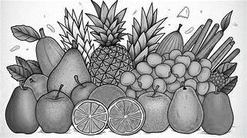Look at the picture below!

Ika : What do you like?

          Mira : I like… .

a. fruits b. vegetebles c. juice

1. Look at the picture below!

Bima : What fruit do you like?

     Wira : I like… .

a. watermelon b. mango c. matoa

1. 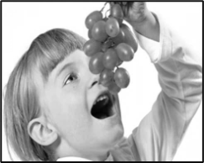Look at the picture below!

Dita : What fruit do you like?

Santi : I like… .

a. rambutans b. grapes c. lemon

1. 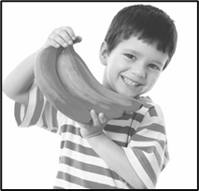Look at the picture below!

Doni : What fruit do you like?

Diko : I like… .

a. mango b. bananas c. pineapples

1. 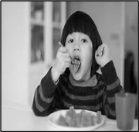Look at the picture below!

Dika : Do you like mango?

Dimas : … .

a. no, I like b. no, I don’t c. yes, I do

1. Look at the picture below!

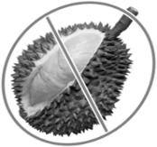Ayu : Do you like durian?

Fina : … .

a. yes, I do b. yes, I don’t like c. no, I don’t like

1. Look at the picture below!

Nana : Do you like strawberry?

Vira : … .

a. yes, I do b. b. yes, I don’t c. no, I don’t

1. Look at the picture below!

Cika : Do you like lemon?

Sita : … .

a. yes, I don’t like b. no, I don’t like c. yes, I like

1. “aku suka nanas”.

Dalam Bahasa Inggris menjadi… .

a. l like snakefruit b. l like grape c. l like pineapple

1. “Dika suka alpukat”.

Dalam Bahasa Inggris menjadi… .

a. dika likes avocado   b. dika likes matoa c. dika likes mango

1. “My mother likes snakefruit”.

Dalam Bahasa Indonesia menjadi… .

a. nenekku suka duku b. ibuku suka salak c. ibuku suka nanas

1. “My Aunt likes banana”.

Dalam Bahasa Indonesia menjadi… .

a. bibiku suka mango    b. bibiku suka apple     c. bibiku suka pisang

1. Does my brother like apple?

a. yes, he does

b. no, he don’t

c. yes, she don’t

1. “She likes banana?”

a. no, she likes matoa

b. no, she likes mango

c. yes, she likes

1. “Snakefruit”. In indonesia is… .

a. salak b. buah naga c. rambutan

1. “Pineapple”. In indonesia is… .

a. semangka b. nanas c. anggur

1. “Watermelon”. In indonesia is… .

a. melon b. semangka c. pepaya

1. What do you say… .

a. there is a bag

b. there are clock

c. there is a clock

1. 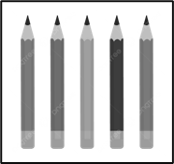 What do you say… .

a. there are four pens

b. there are five pencils

c. there are six pencils

1. 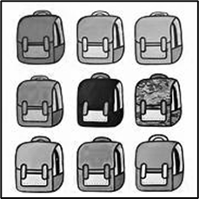What do you say?

a. there is nine bag

b. there are eight bags

c. there are nine bags

1. “Meja” in english is… .

a. table b. chair c. ruler

1. “Rautan pensil” in English is … .

a. ruler b. sharpener c. eraser

1. 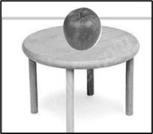Where is my apple?

a. in table

b. on chair

c. on the table

1. “didalam”. In english is… .

a. in    b. on the bag        c. under

1. “kucingku dibawah meja”. In english is… .
2. my cat is in the table
3. my cat is under the table
4. my cat is on the table
5. **Ayo pasangkan pertanyaan dengan jawaban yang benar!**

|  |  |  |
| --- | --- | --- |
| **No.** | **Pertanyaan** | **Jawaban** |
| 1. | • | • Sharpeners |
| 2. | • | • Ruler |
| 3. | • | • Snakefruit |
| 4. | • | • Pineapple |
| 5. | • | • Cupboard |

1. **Jawab dengan singkat pertanyaan di bawah ini!**



1. Do you like mango?
2. “I don’t like papaya”.

Bahasa indonesianya adalah… .

1. “Ada satu pensil”.

Bahasa inggrisnya adalah… .

1. “There is a banana”.

Bahasa indonesianya adalah… .

1. ( in / on / under )



There are books … . the table.